訪問線上帳戶和數位版本(Access to Online Account and Digital Editions – ASIA)
<<以下這些步驟，前提是國外的系統上須有建立客戶的EMAIL為原則>>
- 使用以下連結(Use the following link): www.subscribenow.com.au/time/asia/solo/sso
- 客戶將被引導至以下頁面(The customer will be directed to the page below)
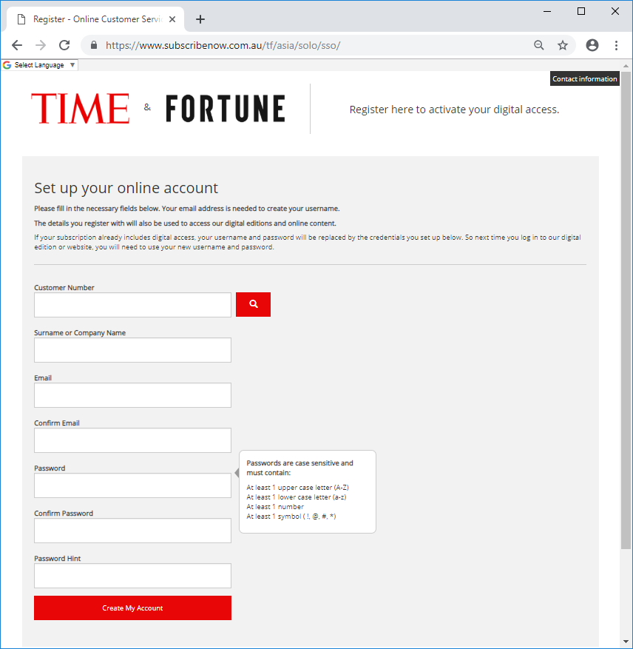

- 所有欄位都為必填欄位(All fields are mandatory)
紅色框的欄位將驗證回資料庫。我們需要將客戶的電子郵件地址保留在資料庫中,以便客戶註冊,因此需要提供任何新訂單或續訂(如果我們的檔中沒有電子郵件地址)
綠色框的欄位是必要欄位,但它無法驗證回資料庫。它不能留空,但我們不驗證此欄位上的存取權限,因此不需要匹配我們的資料庫。
藍色框的欄位供客戶完成
The fields with a red box around them validate back to the database. We need to hold the email address of the customer on the database to allow the customer to register, so this needs to be supplied with any new orders or renewals (if we do not have the email address on our file)
The field with a green box around it is a mandatory field but it is not validating back to the database. It cannot be left blank, but we are not validating access on this field, so does not need to match our database.
The fields with a blue box around them are for the customer to complete
客編:開頭為0的12碼
收書姓名
電子信箱
確認電子信箱
密碼提示
再次確認密碼
客戶自行設置密碼(至少要一個英文大寫/一個英文小寫/一個數字/一個符號!,@,#,*)
完成如下，會打綠色的勾，就可以點擊”創建帳戶Create My Account”
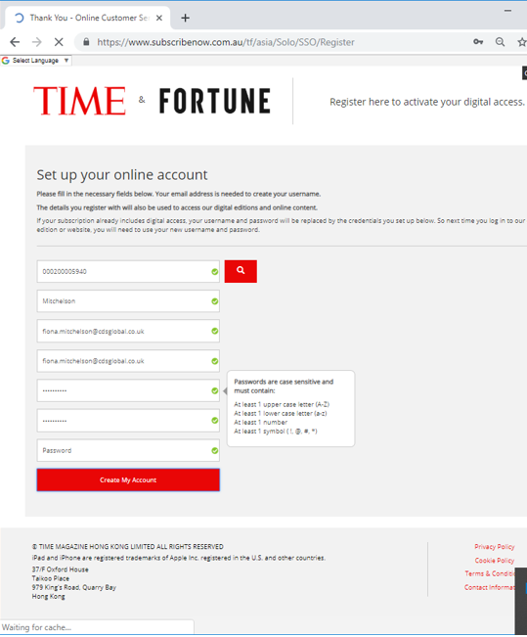

- 一旦客戶按一下"創建我的帳戶",將顯示以下內容。
這是一個保留頁,並通知客戶電子郵件已發送給他們
Once the customer has clicked “Create My Account” the following will appear.
This is a holding page and notifies the customer that an email has been sent to them
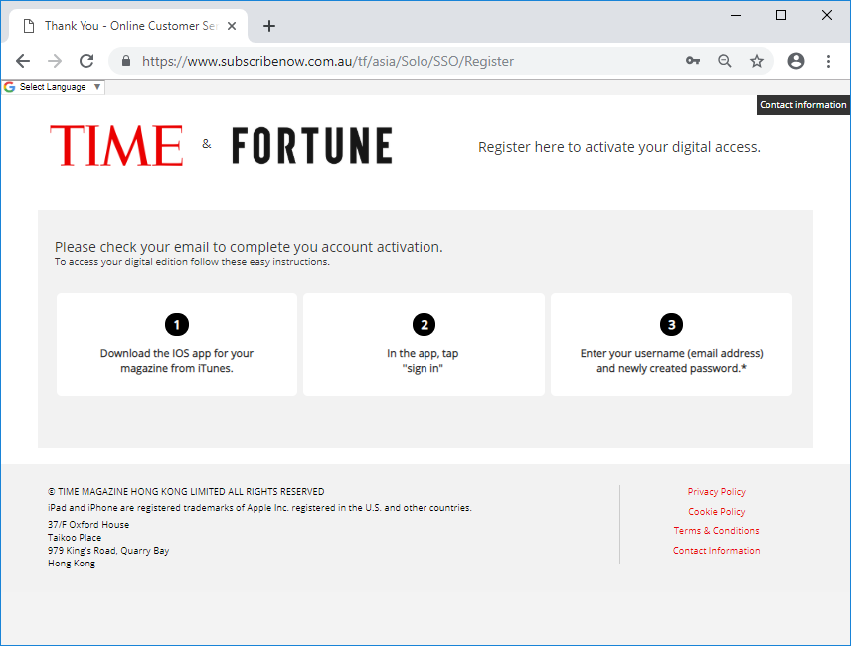

電子郵件如下所示
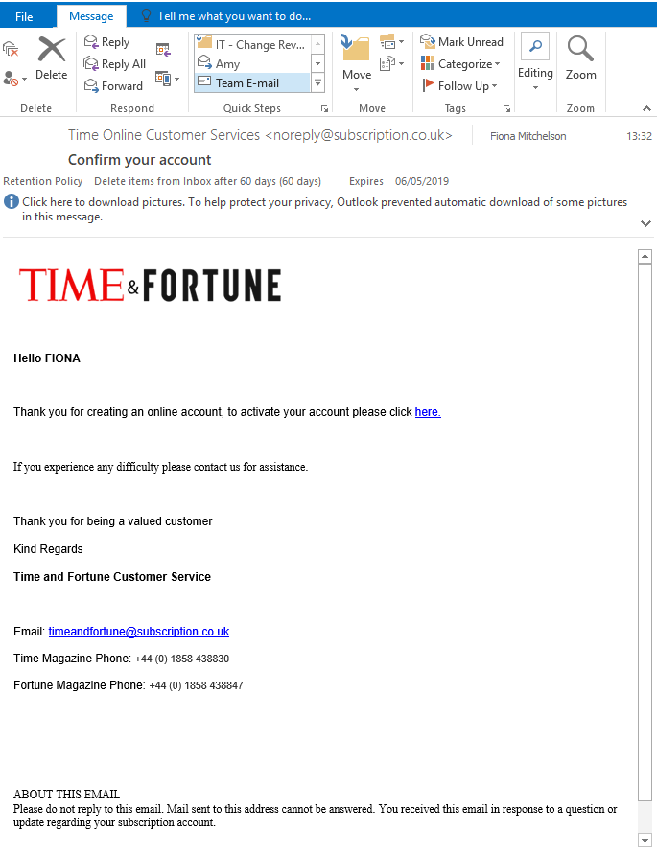
- 客戶需要"按一下此處"連結來最終確定步驟。
完成此操作後,將顯示最後一頁,如下所示
The customer needs to use the “click here” link to finalise the step.
Once this is done the final page will appear, as below
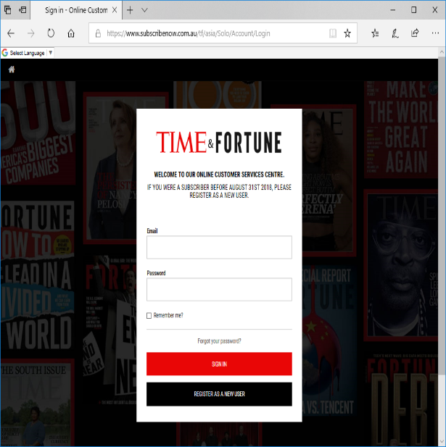
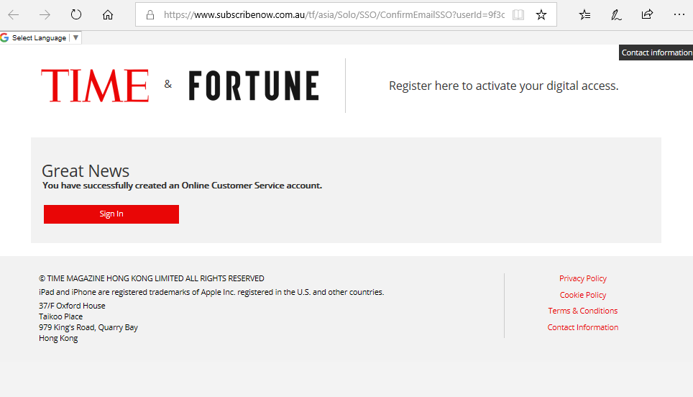
- 如果客戶按一下"登錄",這將帶到以上頁面,登錄後進能看到自己的詳細資料如客編、到期日，但不是從這裡觀看電子版。
If the customer clicks “Sign In” this will take me to the page below where they can sign in.
This link will only take you to the customer service page.
When the customer signs in to the Customer Service Site they can look at their account details. They cannot access digital editions from this area.

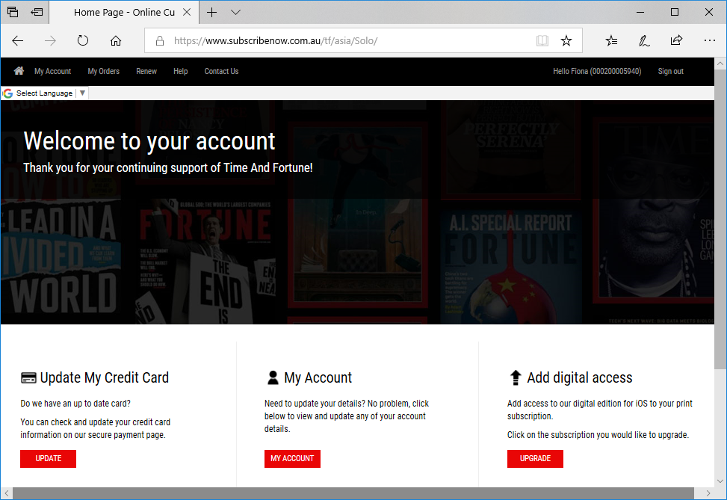
- 要訪問電子版，他們需要在設置密碼後按照以下說明操作。
1.在您的IOS設備上下載TIME Magazine Asia應用程序。
2.點擊“登錄”。
3.輸入您的用戶名（電子郵件地址）和新創建的密碼。
* TIME Magazine Asia電子版可通過此用戶名和密碼用於iPad®和iPhone®。
要訪問網頁版，訂戶需要訪問這個網站→https://time.com/vault/

To access digital editions they need to follow the instructions below once the password has been set up.
1. Download the TIME Magazine Asia app on your IOS device.
2. Tap "Sign in".
3. Enter your username (email address) and newly created password.*
*TIME Magazine Asia digital edition is available for iPad® and iPhone® via this username and password.
To access The Vault subscribers need to go to the site below
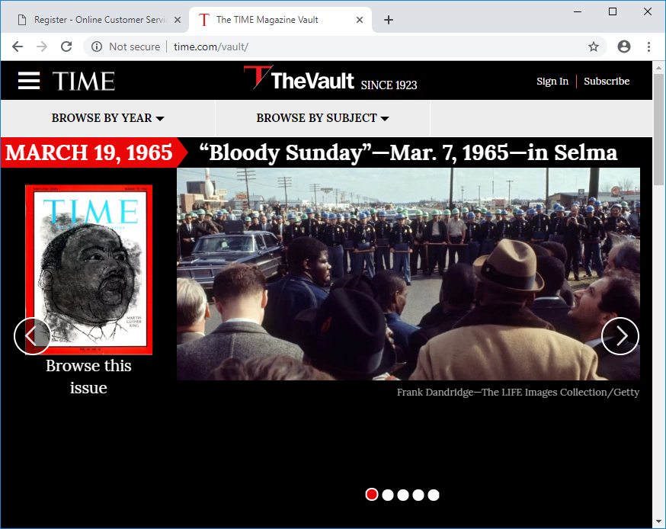
time.com/vault

